Our codebase has structure but is very unclear after reading after a long time, we need better structure and more documentation

I have tried to classify and have identified the following things. Let’s make use of this for adapting to a better architecture

View
The below is the structure of the ‘driver program’(forwarder.cpp)
Given first for clarification of how calls are done
Left part is the driver program and Right part is the core part that interacts with the hardware
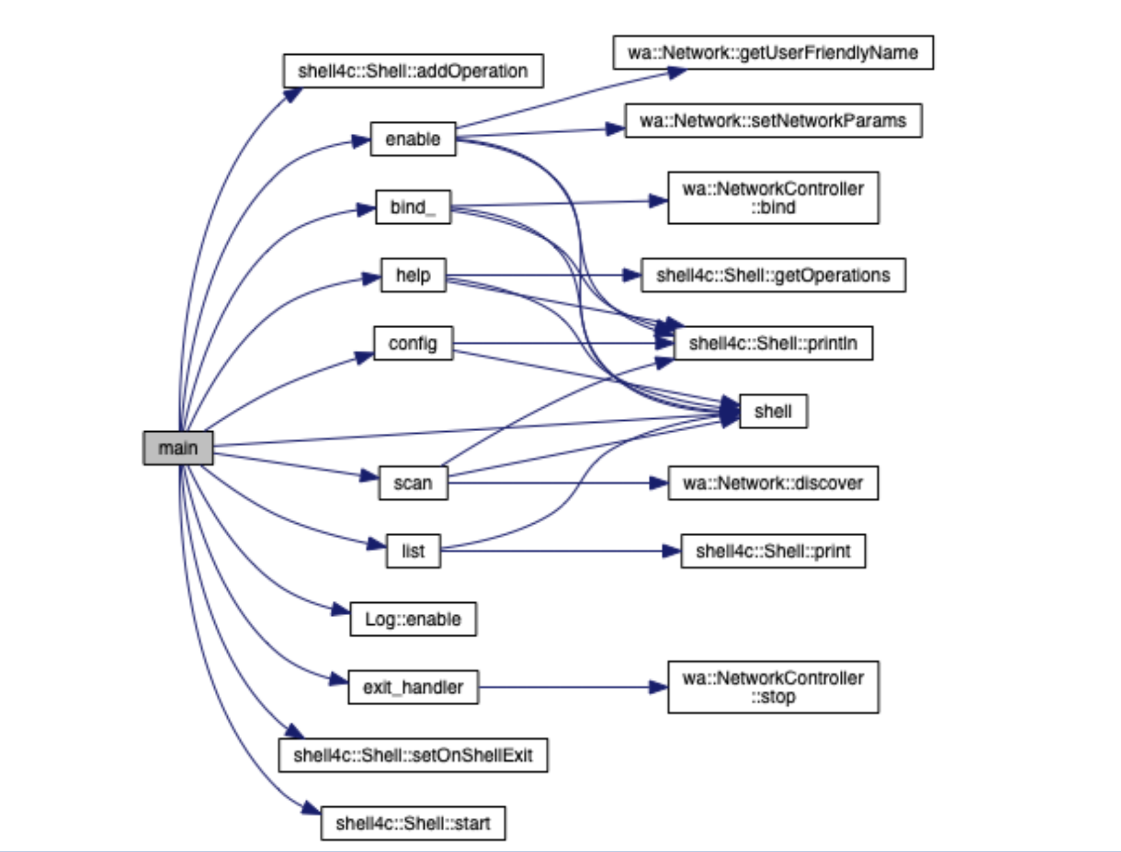
Left part should be considered as the View when we go for MVC, MVVM, or clean or any other architecture for that matter
Entities
Most of the time entities are saved to the databases. But we wouldn’t be doing that instead we create and destroy them whenever needed. We might just save the logs but that’s it

Currently I identified the following two as entities in our codebase:

DeviceInfo
class DeviceInfo {
public:
std::string address;
std::string name;
Network *network;
};

NetworkConfiguration
class NetworkConfiguration {
public:
Network *network;
Medium *medium;
};

Interfaces

We have the following interfaces
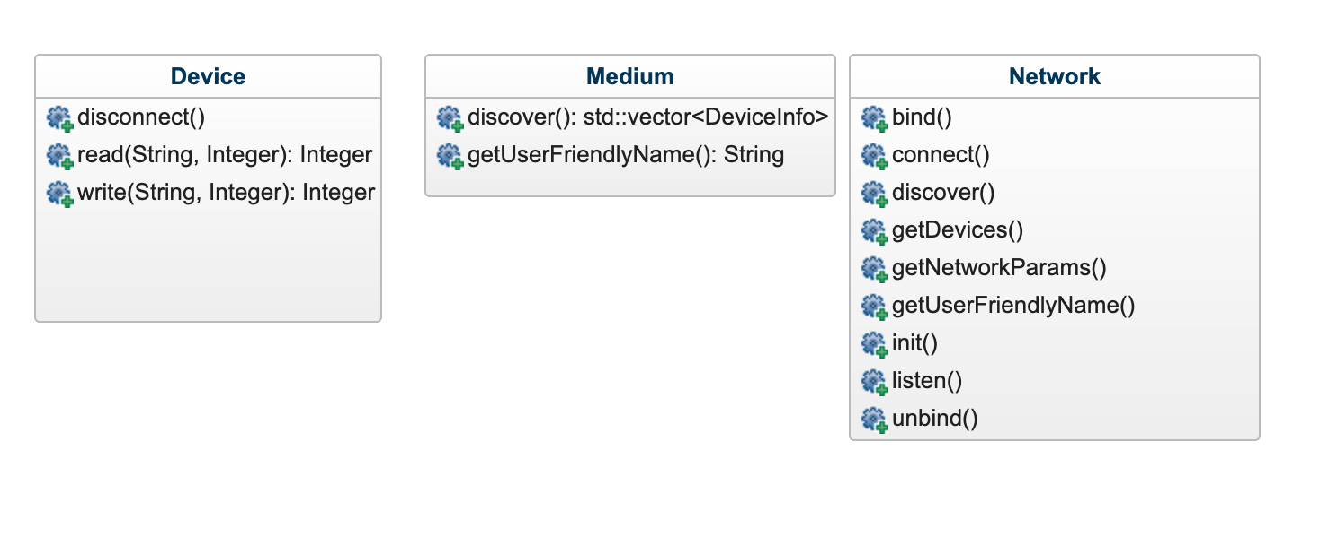
I think they can be split into more interfaces. Some thoughts for introducing new interfaces
1. Adding ‘Discoverable’ interface
Medium and Network can both inherit Discoverable for `discover`

2. Adding ‘Identifiable’ interface
Medium and Network can both inherit Identifiable for `getUserFriendlyName`

Making them more modular :)

Things I don’t know how to classify
ConfigurationBuilder - We can set the Medium(WiFi, etc) and Network(IP,etc)
Forwarder - Takes two devices and creates a ‘pseudo tunnel like thingy’ (Someone work on this terminology please)
NetworkController - Starts the server for incoming connections

